***User Stories – Lord Of The Torreznos***

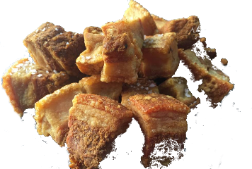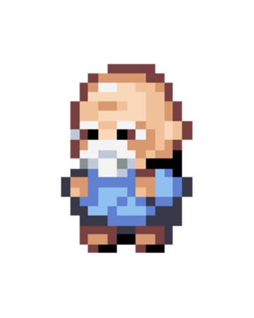

* Welcome to Torreznoland, the land of the dreams, an utopic country in which most of the population has achieved technollogical supremacy thanks to the nutrients obtained eating torreznos.
* Unfortunately, you were born long ago, in the pre-torrezno age, and are now an Elder left for dead in an old asylum. Will you be able to escape?
* The user will spawn in his room. This is the starting point of the game. The player has 4 available options:

1. **Move:** the player can move freely in an giant open world where he has to explore the asylum where he is trapped. Uncover the secrets lying behind and finding clues to escape.
2. **Interact:** The world is vast and full of people willing to give you deep and interesting conversations. TRADE, SELL, BUY, form SENTIMENTAL bounds, and make Friends to help you get through the different tests.
3. **Consume TORREZNOS:** In this universe, torreznos are a precious currency and source of energy and power. In order to become powerful and defeat your reckless enemies, you will have to obtain and then consume this *delicatessens.*
4. **Exit:** Leave this world from a torrezno overdose.